Buddy Session!



Introducing the Buddy Session: Learning From the Pros 🤝

While self-study is a fantastic way to build your foundation, nothing beats the insight and guidance of a senior showing you their top skills in action.

Enter the Buddy Session—your opportunity to learn directly from seasoned experts. This is your chance to connect with the Onboarding Executives.

But it’s more than just a meet-and-greet! These sessions will help you:
- Get to know your senior teammates better.
- Understand their workflows.
- Learn how to communicate effectively as a team when handling merchants.

Your Buddy Session Schedule 📅

You’ll participate in three Buddy Sessions, each designed to expose you to a specific role:

- Day 4 | 10:30 AM – 12:00 PM: Buddy Session with Onboarding Executives

What’s Expected During the Sessions ✍️

- Ask Questions: Come prepared with queries and ask away! Use this time to dig deep into their workflows and responsibilities.
- Observe: Pay close attention to their processes and how they manage tasks.
- Record Your Learnings: Create a copy of the Buddy Checklist Template to document everything you learn. This checklist will serve as a record for you and will be reviewed by your trainer.

Checklist Example 📝
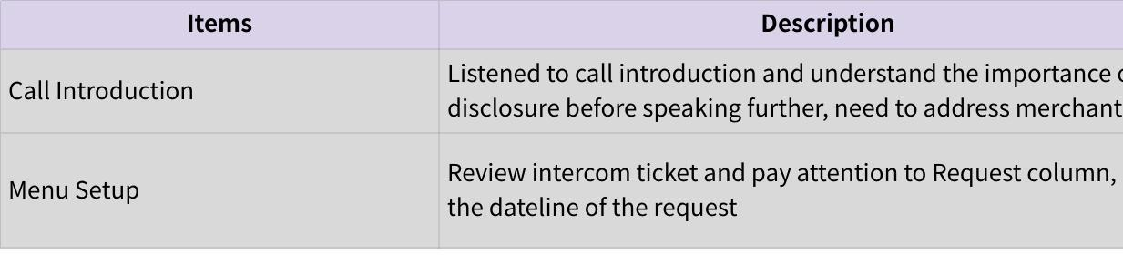
Click the image to view the sheet.

Take full advantage of these sessions—they’re not just informative, but also your gateway to building stronger relationships with your team. Remember, the more you engage, the more you’ll learn. Good luck! 🚀

